**How to Get Away with Murder Season 7: Release Date and other details!** 

**How to Get Away with Murder**, an American legal drama, mystery, and thriller genre television series created by Peter Nowalk, and produced by Shonda Rhimes and ABC Studios. It's one of the widely acknowledged television series which provided name and fame to many cast especially **Viola Davis** starred as **Annalise Keating** who became the first African-American to achieve the "Triple Crown of Acting" by winning an Academy Award, a Primetime Emmy Award, and two Tony Awards. This series also received worldwide acclaim winning many awards and nominated for around 60 awards.

**How to Get away with Murder Season 7: Release Date**

***How to Get away with Murde***r started its premiere on **ABC** on September 25, 2014, and wrapped up with season 6 on May 14, 2020. **Season** 1 aired from September 25, 2014, to February 26, 2015. Season 2 aired from September 24, 2015, to March 17, 2016. **Season** 3 premiered from September 22, 2016, to February 23, 2017. Season 14 premiered from 28, 2017 to March 15, 2018. Season 5 streamed from September 27, 2018, to February 28, 2019. On May 10, 2019, the show was renewed for Season 6 and it was announced on July 11, 2019, that Season 6 will be the final season of the show. And then **Season** 6 was aired from September 26, 2019, to May 14, 2020, as the last and final season of How to Get Away with Murder wrapping up the storyline covering all the characters. And after that, there's no official news on the **release** of ***How to Get Away with Murder Season 7*** from the creators' side.

**How to Get away with Murder Season 7: Probable Cast and Plot**

Since the creator always planned for Season 6 as the concluding one wrapping up everything so there're almost no chances for **Season 7**. But if the creator plans to renew the series for another season then the protagonists of the show are likely to reprise their roles for the same. So, lets' catch up on a few lead characters who appeared in the previous seasons of the show and are likely to appear in ***Season 7*** of the thriller series.

***Viola Davis*** being ***Annalise Keating***- She's a high-profile criminal defense attorney and law professor at Middleton University, whose life is entangled between mysteries of many murders.

Billy Crown being Nate Lahey- He's a Philadelphia police detective who was having love affairs with Annalise at the start of the series.

Alfred Enoch being Wes Gibbins- He's one of the students of Annalise who interns with her about whom she's so much protective. He plays the role of the son of Christopher Castillo, Wes, and Laurel in Season 6.

Jack Falahee being Connor Walsh- He's also a member of the Keating 5, a group of 5 students who interns with Annalise and gets trapped in a series of murders and tries to cover up everything. He's very diligent and crafty.

Aja Naomi King being Michaela Pratt- She's a high-flying overachiever and member of Keating 5 who's keen on making her life successful. 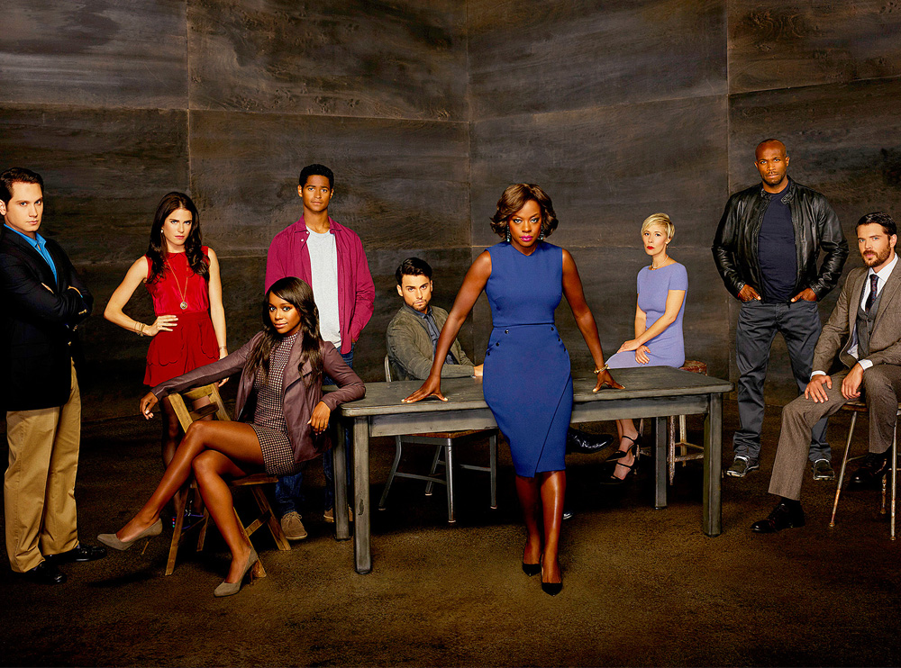

Matt McGorry being Asher Millstone- he's also a member of Keating 5, who feels left out of the group because of him hailing from a fortunate WASP (White Anglo-Saxon Protestants) background.

Karla Souza being Laurel Castillo- She's a wealthy member of Keating 5, whose father controls an organized crime empire.

Charlie Weber being Frank Delfino- He's Annalise's private detective.

And others. So, as we saw all seasons of ***How to Get Away with Murder*** revolved around six characters i.e., Annalise and five members of Keating 5. And as we talked before there're nil chances for the show to return for another season as it concluded with six properly made seasons. But still, if anyhow creators announce to make another season then ***Season 7*** will likely revolve around those 6 characters mostly focusing on Annalise's future. It may also shed some light on Sandarine's fate enlightening what happened to her I.e., if she's dead and if she's then who killed her. So, there're many things left to be explored yet.

**How to Get away with Murder Season 7: Trailer**

Since we already discussed before that **Season 7** is not likely to be released so there's no **release** of the **trailer** of the same but you can enjoy the ***trailer*** of **Season** 6😊

https://www.youtube.com/watch?v=buUuev4yu_8